**Title**

Distinct navigation behaviors in *Aedes*, *Anopheles*, and *Culex* mosquito larvae

**Running Title**

Navigation behavior in mosquito larvae

**Keywords**

Mosquito, navigation, chemosensory, larvae, disease vector, *Aedes*, *Anopheles*, *Culex*

**Author Information**

Eleanor K. Lutza, Kim T. Haa, and Jeffrey A. Riffellab

a: University of Washington Department of Biology, Box 351800, Seattle, WA 98195

b: Corresponding author, jriffell@uw.edu

**Abstract**

Mosquitoes spread deadly diseases that impact millions of people every year. Understanding mosquito physiology and behavior is vital for public health and disease prevention. However, many important questions remain unanswered in the field of mosquito neuroethology, particularly in our understanding of the larval stage. In this study, we investigate the innate exploration behavior of six different species of disease vector mosquito larvae. We show that these species exhibit strikingly different movement paths, corresponding to a wide range of exploration behaviors. We also investigate the response of each species to an appetitive food cue, aversive cue or neutral control. By contrast to the large differences in exploration behavior, all species appeared to gather near preferred cues through random aggregation rather than directed navigation and exhibited slower speeds once encountering food patches. Our results identify key behavioral differences among important disease vector species, and suggests that navigation and exploration among even closely related mosquito species may be much more distinct than previously thought.

**Introduction**

Mosquitoes are global disease vectors that transmit diseases such as malaria, Chikungunya, and dengue fever. To limit the spread of these disease vector mosquitoes, researchers have identified larval mosquito control as a highly effective public health tool [1](https://paperpile.com/c/iwdgYc/0pGC). In particular, naturally occurring larvicides such as methionine and *Bacillus* sp.bacteria have recently increased in popularity as an environmentally safe alternative to synthetic insecticides like DDT [1,2](https://paperpile.com/c/iwdgYc/c8p0+0pGC). These larvicides must be ingested by larvae to be effective, and many factors affect larval feeding rate, including foraging strategy, chemosensory preference, and competition with conspecifics or individuals from other species [3–5](https://paperpile.com/c/iwdgYc/Ctr8+I0BL+GHhw). In addition, larval behaviors and development rate also play an important role in adult population levels. For instance, direct competition for limited food resources at the larval stage is thought to be a major factor in the presence of certain disease vectors [6,7](https://paperpile.com/c/iwdgYc/KxL2+ZzoS). Qualitative studies of mosquito larvae have shown different patterns of feeding and swimming behaviors [4,5,8](https://paperpile.com/c/iwdgYc/PnSR+I0BL+GHhw), although these inter-species differences appear to be flexible and dependent upon the environment [8](https://paperpile.com/c/iwdgYc/PnSR). Despite growing interest [9–11](https://paperpile.com/c/iwdgYc/a5qV+xjtF+11xn), the strategies larvae use to locate sources of food, or respond to environmental stimuli, including sources of nutrients or toxic chemicals, remain poorly understood across many disease vector species. A better understanding of larval navigation and foraging behavior across mosquito species may help inform vector control techniques by suggesting where, when, and how much ingestible larvicide to apply to maximize mosquito control while minimizing cost and environmental impact.

Comparative approaches can provide important insights into the sensory- and evolutionary-bases of behavior. Despite the limited data on chemosensory behaviors by mosquito larvae, previous work has demonstrated differences across species in locomotion and responses to food-related stimuli [9](https://paperpile.com/c/iwdgYc/a5qV), with these differences attributed to the adaptive use of nutrient resources and impacts of competition. For instance, multiple species of *Culex* or *Aedes* larvae may inhabit spatially-restricted containers where individuals experience interspecific competition for limited resources [6,8,12,13](https://paperpile.com/c/iwdgYc/PnSR+Ki6L+KxL2+CcWZ). Although these species may exhibit differences in locomotory and feeding responses, like suspension feeding or browsing on surfaces, they can exhibit similar behaviors when experiencing similar environmental resources, like browsing on the surface of a leaf [8](https://paperpile.com/c/iwdgYc/PnSR). Larval resource use and competition have important effects on adult body size, and in the case of *Aedes albopictus*, can increase arboviral infection. Characterizing larval behaviors under different chemosensory conditions may allow determining how different species respond to different microhabitats or competitive environments.

Mosquito larvae may also provide important insight into the algorithms associated with search behaviors by aquatic insects. A previous study has shown that *Aedes aegypti* larvae find food randomly, rather than demonstrating directed motion toward preferred cues. Once a food-rich area is located, larvae decrease their swimming speed to remain in the favorable environment [14](https://paperpile.com/c/iwdgYc/WxZw). Previous studies in *Anopheles albimanus* [15](https://paperpile.com/c/iwdgYc/7Vv8) and *Aedes vexans* [*16*](https://paperpile.com/c/iwdgYc/2URz) larvae showed that these species also discover food at random, although the methods used in these studies prevented deeper analysis into the mechanism of navigation. This is an unusually simple foraging strategy rarely found in other insects, or even in adult mosquitoes [17](https://paperpile.com/c/iwdgYc/s0sy). Do other disease vector mosquito species also forage by randomly encountering food cues?

In this study we investigated the foraging and navigation behavior of six species of mosquito larvae, drawn from the three major disease vector genera *Aedes, Anopheles,* and *Culex* [18](https://paperpile.com/c/iwdgYc/afsZ) (Fig 1A). These species were selected for their importance to public health and for their diversity in ecological specialization and habitat choice. In the *Aedes* genus we investigated *Ae. aegypti* and *Ae. albopictus* - the most important vectors of dengue fever and yellow fever. Although these two species are closely related, *Ae. aegypti* preferentially breeds in manmade containers [19](https://paperpile.com/c/iwdgYc/fqZ5) while *Ae. albopictus* is a generalist that may also inhabit rural and forested areas [20](https://paperpile.com/c/iwdgYc/k6TQ). In the *Anopheles* genus we examined the malaria vectors *Anopheles arabiensis* and *Anopheles coluzzii*. Interestingly, although *An. arabiensis* and *An. coluzzii* inhabitat similar human-associated larval habitats [21,22](https://paperpile.com/c/iwdgYc/5z7P+6rwG), *An. arabiensis* drastically outcompetes *An. coluzzii* in mixed-species larval competition [3](https://paperpile.com/c/iwdgYc/Ctr8). This suggests that these closely related species may rely on different foraging strategies, and that larval habitat specialization may not solely predict foraging behavior. Finally, we investigated *Culex quinquefasciatus*, a container-breeding mosquito, and *Culex tarsalis*, which breed in large vegetative areas such as rice fields. These two *Culex* species exhibit oviposition behavior that correspond to predation risk in their natural larval habitat (high risk and high predator avoidance for *C. tarsalis*, low risk and low predator avoidance for container-dwelling *C. quinquefasciatus*) [23](https://paperpile.com/c/iwdgYc/ZNNh). Our exploratory study reveals striking differences in exploration behavior between all six species.

**Results**

***Larval exploration behavior in clean water***

To study the navigation behavior of each mosquito species, we used a semi-automated video analysis method previously reported in [14](https://paperpile.com/c/iwdgYc/WxZw) (Fig 1B). We first investigated behavior in clean water during the 15 minute acclimation period (*Ae. aegypti* n=67; *Ae. albopictus* n=70; *An. arabiensis* n=93; *An. coluzzii* n=108; *C. quinquefasciatus* n=110; *C. tarsalis* n=53). The arena size used in these experiments (3x8cm) was chosen based on previous field research showing that 95% of *Ae. aegypti* and *Ae. albopictus* oviposition sites in the field were man-made containers, and that more than a quarter of these observed oviposition sites were under 5cm in radius [24](https://paperpile.com/c/iwdgYc/qU3a), comparable to our experimental arena. Similarly, *An. gambiae* larvae were most commonly found in very small pools such as animal hoofprints in a different field study [25](https://paperpile.com/c/iwdgYc/itOx).

We observed striking behavioral differences across mosquito species in many aspects of exploration behavior (Fig 2A). For example, *C. tarsalis* explored the environment slowly using distinctive sweeping circles (mean number of spirals = 13.1), while the two *Anopheles* species interspersed long rests with fast, straight sprints (*An. arabiensis* mean number of spirals = 0.2; *An. coluzzii* 0.4). The two *Aedes* species, as well as *C. tarsalis*, spent the majority of the time moving (*Ae. aegypti* 56%; *Ae. albopictus* 52%; *C. tarsalis* 46%), albeit at a much lower mean speed (*Ae. aegypti* 0.8 body lengths s-1; *Ae. albopictus* 0.7 BLs-1; *C. tarsalis* 0.7 BLs-1) compared to other species (mean speed 1.3~1.9 BLs-1; time spent moving 9~35%). To further investigate these observations, we quantified ten different aspects of each larval trajectory, based on metrics we believed to be relevant to foraging and exploration behavior (Fig 2B-K). We found significant differences across species in all quantified measures (Fig 2B-K; p<0.001, Kruskal-Wallis test with Holm-Bonferroni correction).

For example, some metrics measure the frequency of exploration behavior in starved larvae, such as time spent moving and total distance traveled. Other metrics quantify known search behavior patterns in insects, such as the looping spirals observed in local-search behavior [26](https://paperpile.com/c/iwdgYc/v51v), frequency of sharp turns, and the number of continuous straight-line paths. Some metrics were added to assess larval response to disturbance. For example, introducing animals to the arena during the acclimation phase is likely to elicit disturbance response to mechanical movement. Thus, we measured the mean speed of animals during the initial minute following introduction to the arena, as well as throughout the entire 15 minute acclimation period. We also calculated a metric subtracting the speed during the initial minute from the last (15th) minute, to quantify the change in larval behavior post-disturbance. Because we found significant differences in larval size across species (Fig S2), we normalized all speed measurements to each individual’s body length (body lengths ⋅ s-1). Finally, some metrics were intended to measure the physiological capacity of the starved larvae, such as the longest rest period and maximum observed speed.

***Exploration differences among species***

We next investigated whether or not these observed differences were consistent with known phylogenetic relationships. In particular, do different species exhibit different trajectory patterns when all navigation variables are considered? To answer this question, we created a Euclidean distance matrix of larval trajectories by incorporating all ten navigation variables (Fig S1). We found significant differences among the six mosquito species (Fig 3, perMANOVA p<0.001, pseudo F=70.7). To visualize these results, we reduced the dimensionality of this data using Principal Component Analysis (PCA) based on the same Euclidean distance matrix (Fig 3A). PC1 and PC2 explained a significant proportion of variation in the data, but not subsequent PC axes (Monte Carlo permutation test, PC1 p<0.001; PC2 p<0.001; PC3-10: p>0.05). In brief, we found that larvae appeared to cluster in ordination space into four distinct categories: very fast animals (upper left); animals that traveled a long distance and conducted many sharp turns (upper right); animals that rested for long periods of time (lower left); and animals that traveled in spiral patterns and changed their behavior drastically during the 15 minute period (lower right).

We next asked if sister mosquito species display exploratory behavior that is more similar to each other than to other species. A post-hoc pairwise perMANOVA for each species-species pair showed that all species differed significantly in navigation from each other, including sister species (Table 1). We observed that both *Aedes* species were more similar to each other than to any other species (comparison of pseudo-F statistics across species-species pairs), and both *Anopheles* species were also closest to each other than to non-sister species. However, *C. quinquefasciatus* was most similar to *Ae. aegypti*, while *C. tarsalis* was most similar to *Ae. albopictus*. It is interesting to note that *C. quinquefasciatus* and *Ae. aegypti* both inhabit man-made containers, while *C. tarsalis* and *Ae. albopictus* can inhabit large vegetated areas such as rice fields and lakes. Although our study only compares six species and is not intended to draw phylogenetic conclusions, our limited panel of results suggest that both evolutionary history and ecological specialization may correlate with similar navigation behaviors in different species.

***Larval response to attractive and aversive cues***

Next, we examined the change in larval behavior after the introduction of 0.5% food extract, 10mM quinine, or distilled water. These stimuli were chosen to investigate larval cue-finding behavior, because previous studies have shown that these cues elicit robust preferences in *Ae. aegypti* mosquito larvae [14,27](https://paperpile.com/c/iwdgYc/WxZw+bAfU). Corroborating a previous study [14](https://paperpile.com/c/iwdgYc/WxZw), we found that *Ae. aegypti* significantly preferred 0.5% food extract. To quantify preference, we normalized the median concentration preferred by each larvae during the experiment phase, to the corresponding larval behavior during the acclimation phase. *Ae. aegypti* preferred a median food concentration of 20% more than would be expected from their pre-experiment behavior (p=0.0002, pairwise t-test). We observed similar attraction for all other species (Fig 4A): *Ae. albopictus* (+32%, p<0.001), *An. arabiensis* (+13%, p=0.005), *An. coluzzii* (+7%, p=0.04), *C. quinquefasciatus* (+14%, p=0.006), and *C. tarsalis* (+16%, p=0.001). Further, we investigated changes in larval behavior after the introduction of 10mM quinine, an aversive tastant. Similar to our previous study [14](https://paperpile.com/c/iwdgYc/WxZw), *Ae. aegypti* significantly avoided quinine, preferring a median concentration of 9% less than would be expected from their pre-experiment behavior (p<0.001). We observed similar aversion in *Ae. albopictus* (-11%, p<0.001), *An. arabiensis* (-7%, p=0.002), and *An. coluzzii* (-7%, p=0.001) (Fig 4A). Interestingly, neither *C. quinquefasciatus* nor *C. tarsalis* exhibited aversion to quinine (*C. quinquefasciatus* p=0.42; *C. tarsalis* p=0.60). In response to the addition of distilled water - a negative control for mechanical disturbance - all species exhibited no change in preference (p>0.05).

We next explored the mechanism of larval navigation to food sources. In our previous work, we found that *Ae. aegypti* explore their environment using a non-directional search strategy that results in random discovery of preferred cues [14](https://paperpile.com/c/iwdgYc/WxZw). In all species in this study, we found that larval preference also appeared to be consistent with random cue discovery. Discovery time did not significantly differ between water, food, and quinine for any species (p>0.05, Kruskal-Wallis test, Fig 4B), suggesting that larvae encounter environmental cues by random chance. In addition, we did not observe strong differences in orientation (Fig 4C) or turn frequency (Fig 4D) between different stimuli for any of the six species. Although surprising, these results are consistent with earlier literature using both video-tracking methods [14](https://paperpile.com/c/iwdgYc/WxZw) and researcher observations [15,16](https://paperpile.com/c/iwdgYc/7Vv8+2URz).

In our previous study, we were able to conduct deep analyses and simulations into the mechanism of *Ae. aegypti* navigation, using a dataset of over 500 individual animals observed independently, with approximately 2 million total data points. In this current study, we did not have the necessary data to conduct the simulations or 3,000 experiments necessary for similar analyses across species. Nevertheless, we visualized some of the same behavioral changes as a reference for future experiments (Fig S3, Fig S4, Fig S5). We found several interesting patterns in these datasets. For example, in the vast majority of cases, animals did not appear to change their behavior - such as the number of looped searches or sharp turns - after addition of the stimulus. In cases where animals did change their behavior - such as *An. coluzzii*, which decreased initial speed in the post-stimulus period - animals seemed to exhibit the same behavioral changes for all experiments, independently of the stimulus added. Corroborating our previous results, we found that in our current work, *Ae. aegypti* also appear to aggregate near preferred cues by decreasing their movement speed near preferred areas (Fig S4). Interestingly, we observed the same pattern for *Ae. albopictus* but not for any other species (Fig S4). Similarities between closely related species was reflected in the PCA analyses: whereas the exploration responses were often distinct between species (Figs. 3A, S4K). However, once food was added, all the species significantly slowed their swimming speeds, causing them to cluster in the PCA space (Fig. S4N). Although further experiments are necessary to understand these results, it is likely that the *Anopheles* and *Culex* species in our study use different kinematic changes to navigate with respect to chemosensory cues, such as adjusting their turning frequency.

**Discussion**

Our results raise several interesting questions for future research. In our experiments investigating larval cue-finding, we predicted that larvae may exhibit navigation strategies adapted to their environment, with species living in small containers displaying different strategies than those that breed in larger lakes or streams. However, our results showed that the six different species of mosquito larvae were strikingly homogeneous in their chemosensory responses to food: none of the species were able to change their behavior to find food cues faster in our experimental paradigm. Are there intrinsic physical properties to chemical diffusion in small, stagnant aquatic environments that makes more directed navigation particularly difficult? Although many of the species examined are naturally adapted to habitats of similar size to the experimental arena [9,19](https://paperpile.com/c/iwdgYc/fqZ5+a5qV), it is possible that larvae may exhibit different navigation strategies in larger environments where the chemical gradients may be shallower or influenced by turbulent kinetic motion. Additionally, are there physiological limitations to larval chemosensation, such as the sensitivity of receptors or complexity of neural processing circuits, that prevent larvae from utilizing more complex navigation processes?

Second, is there an evolutionary benefit to different navigation behaviors exhibited by each species in clean water? Interspecific larval competition significantly affects distribution of mosquito species in the wild and in laboratory experiments [3,28,29](https://paperpile.com/c/iwdgYc/cG4x+paYc+Ctr8). It is possible that this competitive environment drives larvae to exploit different foraging niches through different navigation strategies. Alternatively, it is possible that the different environmental conditions preferred by each species, such as lakes, streams, and containers, result in different navigation strategies consistent across habitats. Although our study did not examine enough species to quantitatively answer this question, it is interesting to note that *Aedes* and *Anopheles* mosquito larvae exhibited greater similarity to sister species even when the sister species inhabited vastly different natural larval habitats. By contrast, the two *Culex* species exhibited the greatest similarity toward non-sister species that inhabited similar ecological environments.

It is important to note that our investigative study may not address important characteristics of mosquitoes found in the wild. For example, although all larvae analyzed in this study successfully completed development under the same laboratory rearing conditions, it is likely that environmental variables including temperature, concentration of dissolved organic matter, and water depth were more optimal for some species than others. Indeed, species exhibited significantly different mortality rates post-experiment, suggesting that the 24-hour starvation period may have been more stressful for some species (Fig S2). In addition, our experimental trials only observed larvae for a total of 15 minutes after stimulus addition, and it is possible that larvae may exhibit different behaviors in longer time scales.

Nevertheless, we believe that this study reveals an important area of future research. To our knowledge, this is the first study to quantitatively compare exploration behavior among mosquito larvae using machine vision rather than researcher observations. Even among the small subset of species examined in this study, we saw immediate and clear differences in exploration, stimulus preference, and chemosensory navigation. Future studies incorporating additional mosquito species - especially outgroups that are not disease vectors - would add fascinating comparisons that may help clarify the evolutionary basis of exploration behavior in mosquitoes. Furthermore, with the advent of new tools to examine the sensory bases of behaviors, including binary expression systems for cell-type specific labeling and manipulation [30,31](https://paperpile.com/c/iwdgYc/IXFo+i6np), it may soon be possible to interrogate and functionally link different navigational behaviors with the sensory channels mediating those responses. Because laboratory arena sizes and rearing conditions are already within the natural range of many mosquito species, mosquito larvae may be a promising field for phylogenetic behavior questions from a practical perspective. Finally, our results underscore the importance of understanding disease vector behavior at all life history stages. We suggest that species-specific vector control research may be particularly important to improving disease prevention methods.

**Materials and Methods**

***Mosquitoes***

Six species of wild-type mosquitoes were obtained from BEI Resources (NIAID, NIH): *Ae. aegypti* (Strain COSTA RICA, MRA-726, contributed by William G. Brogdon), *Ae. albopictus* (Strain ATM-NJ95, Centers for Disease Control and Prevention for distribution by BEI, NR-48979), *An. arabiensis* (Strain DONGOLA, MRA-856, contributed by Mark Q. Benedict), *An. coluzzii* (Strain Ngousso, MRA-1279, contributed by Frédéric Simard), *C. quinquefasciatus* (Strain JHB, NR-43025), and *C. tarsalis* (Strain YOLO, NR-43026). All species were reared in milliQ water in a shallow tray (26x35x4cm) and fed with fish food (Petco; Hikari Tropic First Bites). Larvae were reared using the circadian cycle recommended by species-specific BEI rearing guidelines (16:8 light:dark for *C. tarsalis*; 12:12 for all other species). One day before the experiment, L3-stage larvae were isolated in Falcon ™ 50mL conical centrifuge tubes (Thermo Fischer Scientific, Waltham, MA, USA) containing ∼15mL milliQ water. Starved larvae were denied food for at least 24 hours before the experiment. Animals that died before eclosion or pupated during the experiment were omitted, and all animals were tested during the light phase of their circadian cycle.

***Preparation of Odor Stimuli***

Stimuli were used that elicited robust behavioral responses across species. Two stimuli were used: an attractive food solution and quinine, a compound that elicits aversion in *Ae. aegypti* larvae [14](https://paperpile.com/c/iwdgYc/WxZw). The food extract solution was made fresh daily by dissolving 0.5% food (Petco; Hikari Tropic First Bites) in milliQ water for one hour, then passing the mixture through a 0.2μm filter (VWR International #28145-477) to remove solid particulates. Quinine hydrochloride was prepared at 10mM in milliQ water (Aldrich #Q1125).For all species, we saw no difference in mortality between the three treatments (p=1 for all species, Fig S2), suggesting that exposure to quinine or food extract did not significantly harm larvae physiologically.

***Behavior Arena and Imaging***

We computed the trajectories of individual larvae in a custom behavior arena as previously described [14,27](https://paperpile.com/c/iwdgYc/WxZw+bAfU). Briefly, individual larvae were introduced to a 8x3cm rectangular behavior arena containing 20mL of distilled milliQ water. Larvae were allowed to acclimate within the dark arena for 15 minutes, while being recorded by a Basler Scout Machine Vision GigE camera under infrared light. Subsequently, 100µL of one stimulus was pipetted gently into the upper left corner of the arena (Fig 1C), and larval behavior was recorded for an additional 15 minutes. In a separate experiment without larvae, we pipetted 100µL of fluorescein dye into an identically shaped arena, in order to map stimulus concentration within the arena throughout the 15 minute experiment [14](https://paperpile.com/c/iwdgYc/WxZw) (Fig 1C). Trajectory paths were extracted from each video using Multitracker software by Floris van Breugel [32](https://paperpile.com/c/iwdgYc/LBMV) and additional code developed previously [14](https://paperpile.com/c/iwdgYc/WxZw). We visually inspected each trajectory path and manually corrected errors and omissions introduced by the tracking software.

***Trajectory Quantification***

During foraging and swimming behaviors, mosquito larva can exhibit species-specific differences in their swimming kinematics and behaviors, including changing the duration of activity [33](https://paperpile.com/c/iwdgYc/azyy), increasing or decreasing their swim speeds, or exhibiting complex changes in locomotion [5](https://paperpile.com/c/iwdgYc/GHhw). We thus quantified ten aspects of larval navigation in clean water to represent many of these ecologically relevant behaviors. Time spent moving was quantified as a proportion (0-100%), with movement defined as >1mm ⋅ s-1.Total distance traveled was measured in meters.To normalize for any size-specific differences across individuals or species (Fig S2), we converted larval speed measurements into body lengths per second. Experimenters were blind to larval species or sex when measuring body lengths. Thus, body lengths ⋅ s-1 were used for quantifying maximum speed, mean speed when moving, mean speed in first minute, and the difference in mean speed between first and last minutes. Spirals were defined as a distinct time period in which larvae engaged in >4 seconds of continuous spiraling movement. Sharp turns were defined as turns of >45° conducted at a speed of >4mm ⋅ s-1. Continuous paths were defined as sustained movement at the same Δ angle, not including spirals. Rests were defined as periods of time >10 seconds of no movement.

***Statistical Analyses***

Statistical analyses were performed in R [34](https://paperpile.com/c/iwdgYc/d7yq) and in Python [35](https://paperpile.com/c/iwdgYc/1Uos). We used a non-parametric Kruskal-Wallis test with Bonferroni correction to compare navigation characteristics across species for each of the ten aspects of larval navigation (Fig 2), because we found that not all variables followed a normal distribution (Shapiro-Wilk test, p>0.05). To create the Euclidean distance matrix for larval similarity analysis (Fig S1), we first standardized all variables to zero mean and unit variance. To compare larval trajectories across species, both as a group of six and in species-species pairs, we used a perMANOVA and test of multivariate dispersion ANOVA with a Bonferroni correction (Table 1). We used a Monte Carlo permutation test to select significant eigenvectors for visualization in our PCA ordination (Fig 3). We used a pairwise t-test to compare larval preference for different stimuli for each species (Fig 4A). Preference was defined as the median concentration preferred by the larvae during the 15 minute experiment, normalized to the areas chosen by the same larva during the preceding 15 minute acclimation phase. This normalization was necessary to control for innate larval preference for corners or walls reported in some species [14](https://paperpile.com/c/iwdgYc/WxZw). Discovery time across different stimuli were compared for each species using a non-parametric Kruskal-Wallis test (Fig 4B). A non-parametric test was used because we found that discovery time data did not follow a normal distribution (Shapiro-Wilk test, p>0.05). Discovery time was defined as the time taken (in seconds) to first encounter a section of the behavioral arena >=50% concentration, normalized to the time taken to first encounter the same area during the clean water acclimation period. We used a Fisher’s Exact Test with Bonferroni correction to assess mortality differences among larval species, as well as among experimental treatments in larvae of the same species (Fig S2). We used a non-parametric Kruskal-Wallis test to compare body length between different species (Fig S2), because we found that body length data did not follow a normal distribution for all species (Shapiro-Wilk test, p>0.05).

**Acknowledgements**

We thank Floris van Breugel for assistance in developing methods for video data analysis, and Julian Olden for advice on statistical methods. We also thank Binh Nguyen and Kara Kiyokawa for maintaining the Riffell lab mosquito colony, and Dustin Miller for advice on rearing mosquitoes procured from the CDC. Finally, we thank two anonymous peer reviewers for their time and effort in suggesting helpful revisions to this manuscript.

**Author Contributions**

Conceptualization: E.K.L. and J.A.R.; Methodology: E.K.L. and J.A.R.; Software: E.K.L.; Investigation: K.T.H. and E.K.L.; Resources: E.K.L. and J.A.R.; Data Curation: E.K.L. and K.T.H.; Writing - Original Draft: E.K.L; Writing - Review and Editing: E.K.L, J.A.R, and K.T.H.; Visualization: E.K.L. and K.T.H.; Supervision: J.A.R.; Project Administration: J.A.R; Funding acquisition: J.A.R., E.K.L., and K.T.H.

**Competing Interests**

The authors declare no competing financial interests.

**Funding**

This work was supported in part by the National Institute of Health grants RO1DCO13693-04 and R21AI137947 to J.A.R.; National Science Foundation grant DGE-1256082 to E.K.L.; Air Force Office of Sponsored Research under grant FA9550-16-1-0167 to J.A.R.; CoMotion Innovations Scholarship to K.T.H.; Robin Mariko Harris Award to E.K.L.; and the Margo and Tom Wyckoff Award to E.K.L.

**Data Availability**

All code used to analyze data in this manuscript is available at: [https://github.com/eleanorlutz/aedes-aegypti-2020](https://github.com/eleanorlutz/aedes-aegypti-larvae-2020)

**Figures and Figure Legends**

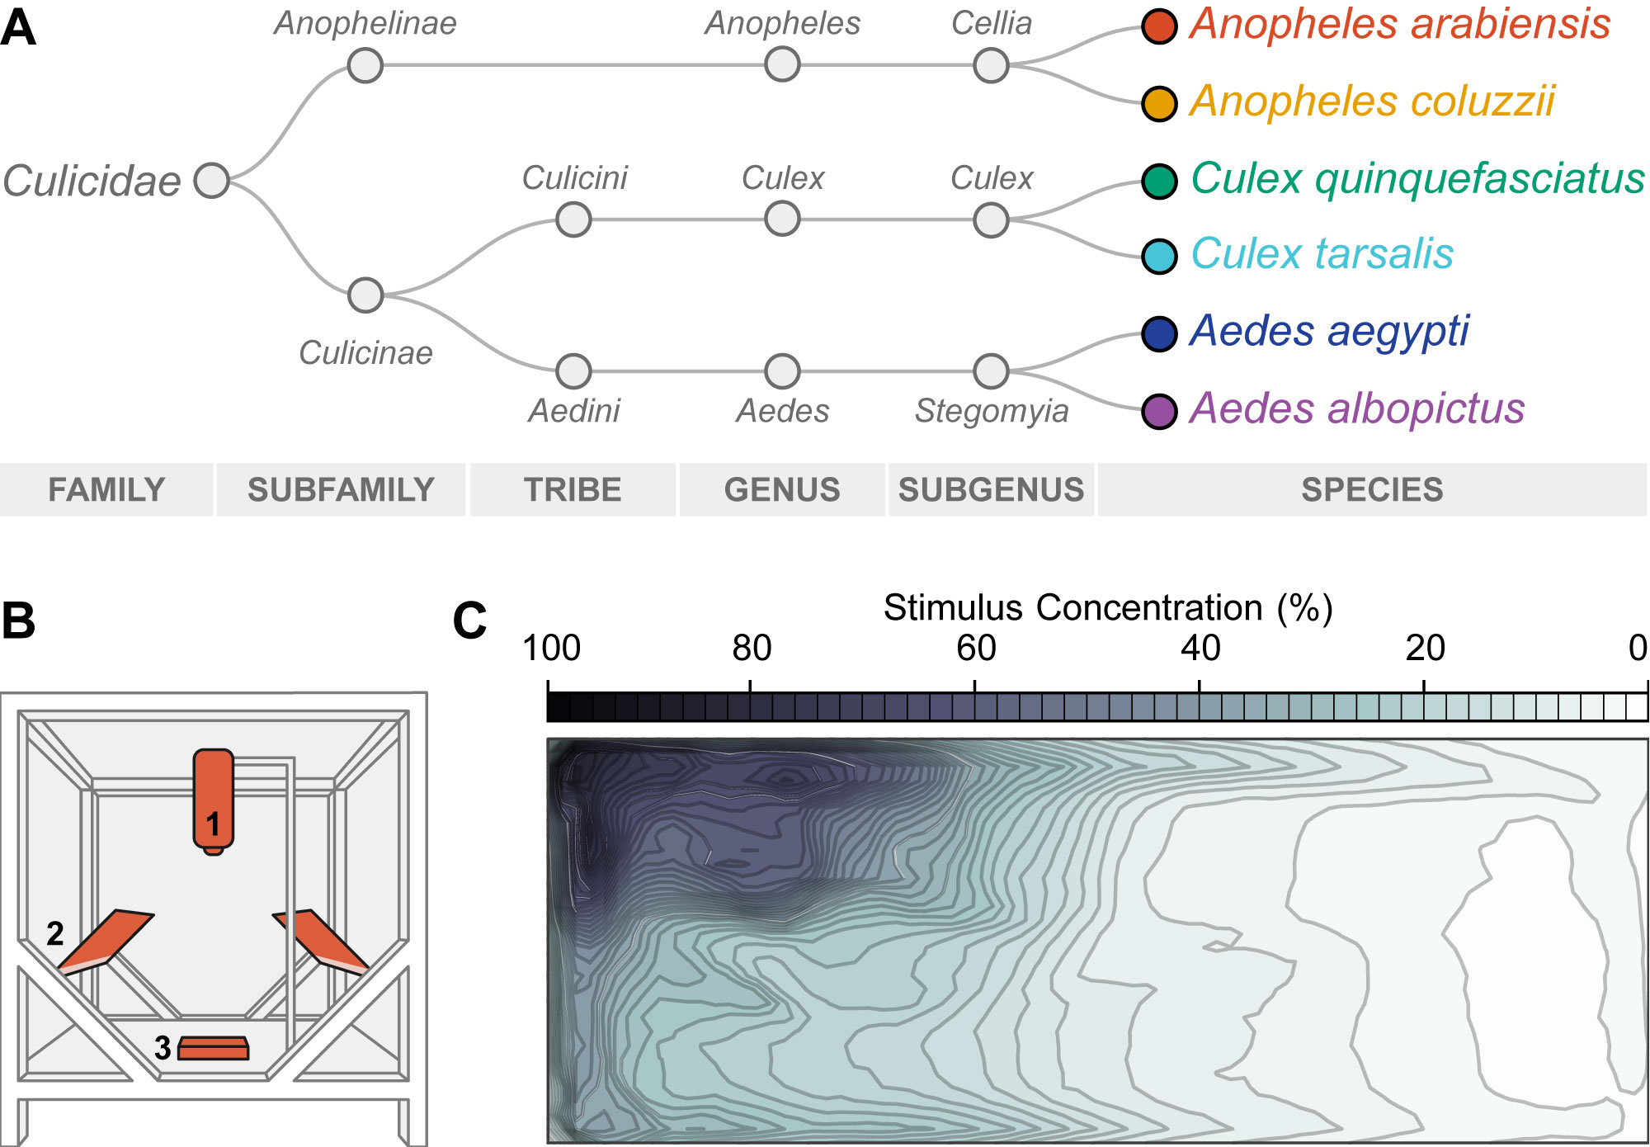

**Fig 1: Summary of experimental design and methods.**

**A:** A simplified phylogeny of the six mosquito species investigated in this manuscript, adapted from[*18*](https://paperpile.com/c/iwdgYc/afsZ) (branch lengths are not representative of phylogenetic distance). **B:** Diagram of the experimental rig, adapted from [14](https://paperpile.com/c/iwdgYc/WxZw), including a Basler Scout Machine Vision GigE camera (**1**), infrared lighting (**2**) and a behavior arena filled with water (**3**). **C:** A map of stimulus distribution within the arena at 15 minutes post-stimulus addition, adapted from [14](https://paperpile.com/c/iwdgYc/WxZw).

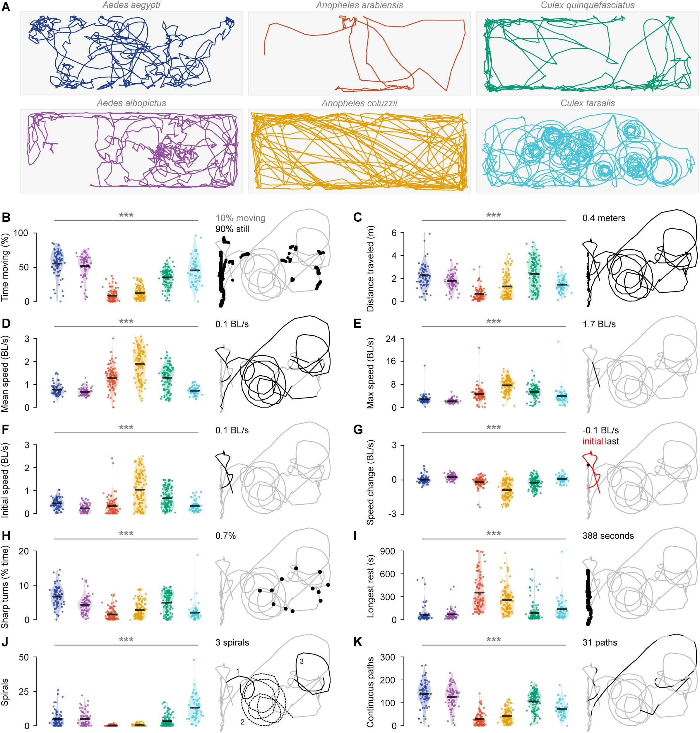

**Fig 2: Larvae exhibit species-specific behavioral differences in the absence of chemosensory stimuli.**

**A:** Example trajectories visualizing one individual from each species, navigating in clean water. **B-K:** Species-specific distributions for each of ten navigation variables quantified from larval behavior in clean water. For each variable a violin plot visualizes the distribution for each species, with scatter points showing values for individual animals. A black bar marks the mean value for each species. Asterisks above each plot represents the significance of differences across species (Kruskal-Wallis test; ***: p<0.001). For all plots, a sample trajectory from a *C. quinquefasciatus* individual is shown on the right in gray, with red and black lines highlighting sections of the trajectory included in that variable. From left to right in all graphs: *Ae. aegypti* (navy); *Ae. albopictus* (purple); *An. arabiensis* (red); *An. coluzzii* (yellow); *C. quinquefasciatus* (green); *C. tarsalis* (aqua). **B:** Time spent moving (%) **C:** Total distance traveled (meters) **D:** Mean speed when moving (body lengths⋅s-1 [BL/s])L **E:** Maximum speed (body lengths⋅s-1 [BL/s]) **F:** Initial speed, or mean speed in first minute (body lengths⋅s-1 [BL/s]) **G:** Speed modification, or difference in mean speed between first and last minutes (body lengths⋅s-1 [BL/s]) **H:** Sharp turns (% total time spent turning >45°) **I:** Longest continuous rest period **J:** Number of spirals **K:** Number of continuous paths that are not spirals.

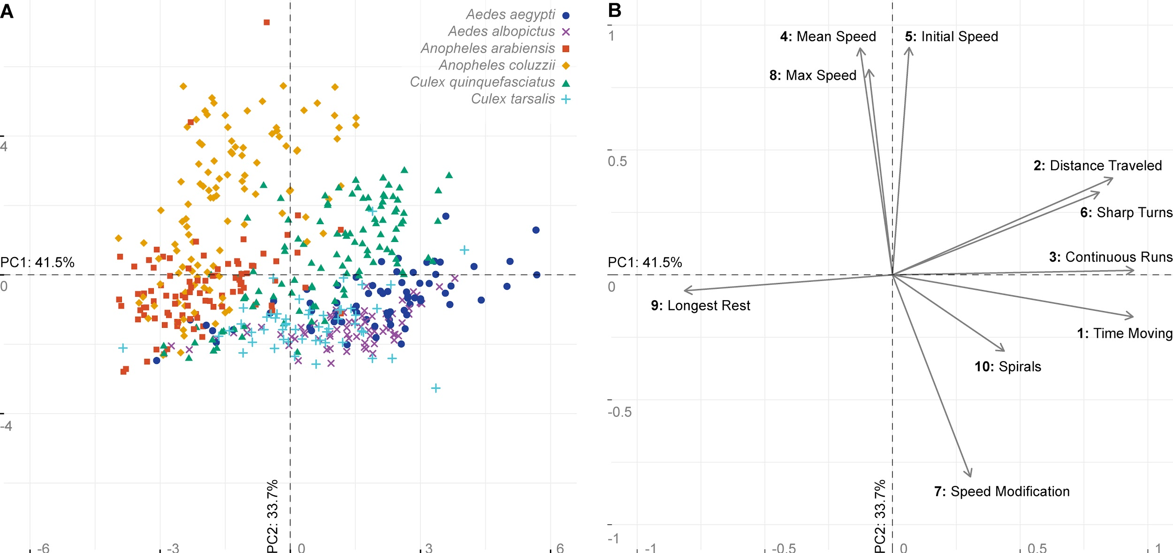

**Fig 3: Larvae exhibit species-specific behavioral differences in the absence of chemosensory stimuli.**

**A:** PCA biplot of ten individual variables describing larval trajectories based on the Euclidean distance matrix visualized in Fig S1. PC1 and PC2 explain a significant proportion of variance in the original data (Monte Carlo test, PC1: 41.5%, p<0.001; PC2: 33.7%, p<0.001), while all other PC axes did not (p>0.05). Scatter points depict individual larvae in the ordination space, colored by species: *Ae. aegypti* (navy circles, n=67), *Ae. albopictus* (purple x markers, n=70), *An. arabiensis* (red squares, n=93), *An. coluzzii* (yellow diamonds, n=108), *C. quinquefasciatus* (green triangles, n=110), and *C. tarsalis* (aqua + markers, n=53). **B:** Vector arrows (**1-10**) indicate the direction of variable gradients in the ordination space. Ordered from highest to lowest contribution to PC1 and PC2, these variables include: **1:** Time spent moving (variable contribution to PC1: 21.4%; PC2: 0.8%); **2:** Distance traveled (PC1: 17.9%; PC2: 4.5%)**; 3:** Continuous paths (PC1: 21.5%; PC2: 0%); **4:** Mean speed (PC1: 0.4%; PC2: 24.5%); **5:** Initial speed in first minute (PC1: 0.1%; PC2: 24.6%); **6:** Sharp turns (PC1: 15.8%; PC2: 3.2%); **7:** Speed modification, or the difference in mean speed between first and last minutes (PC1: 2.2%; PC2: 19.4%); **8:** Maximum speed (PC1: 0.2%; PC2: 20.1%); **9:** Longest rest period (PC1: 16%; PC2: 0.1%); and **10:** Spirals (PC1: 4.6%; PC2: 2.8%)

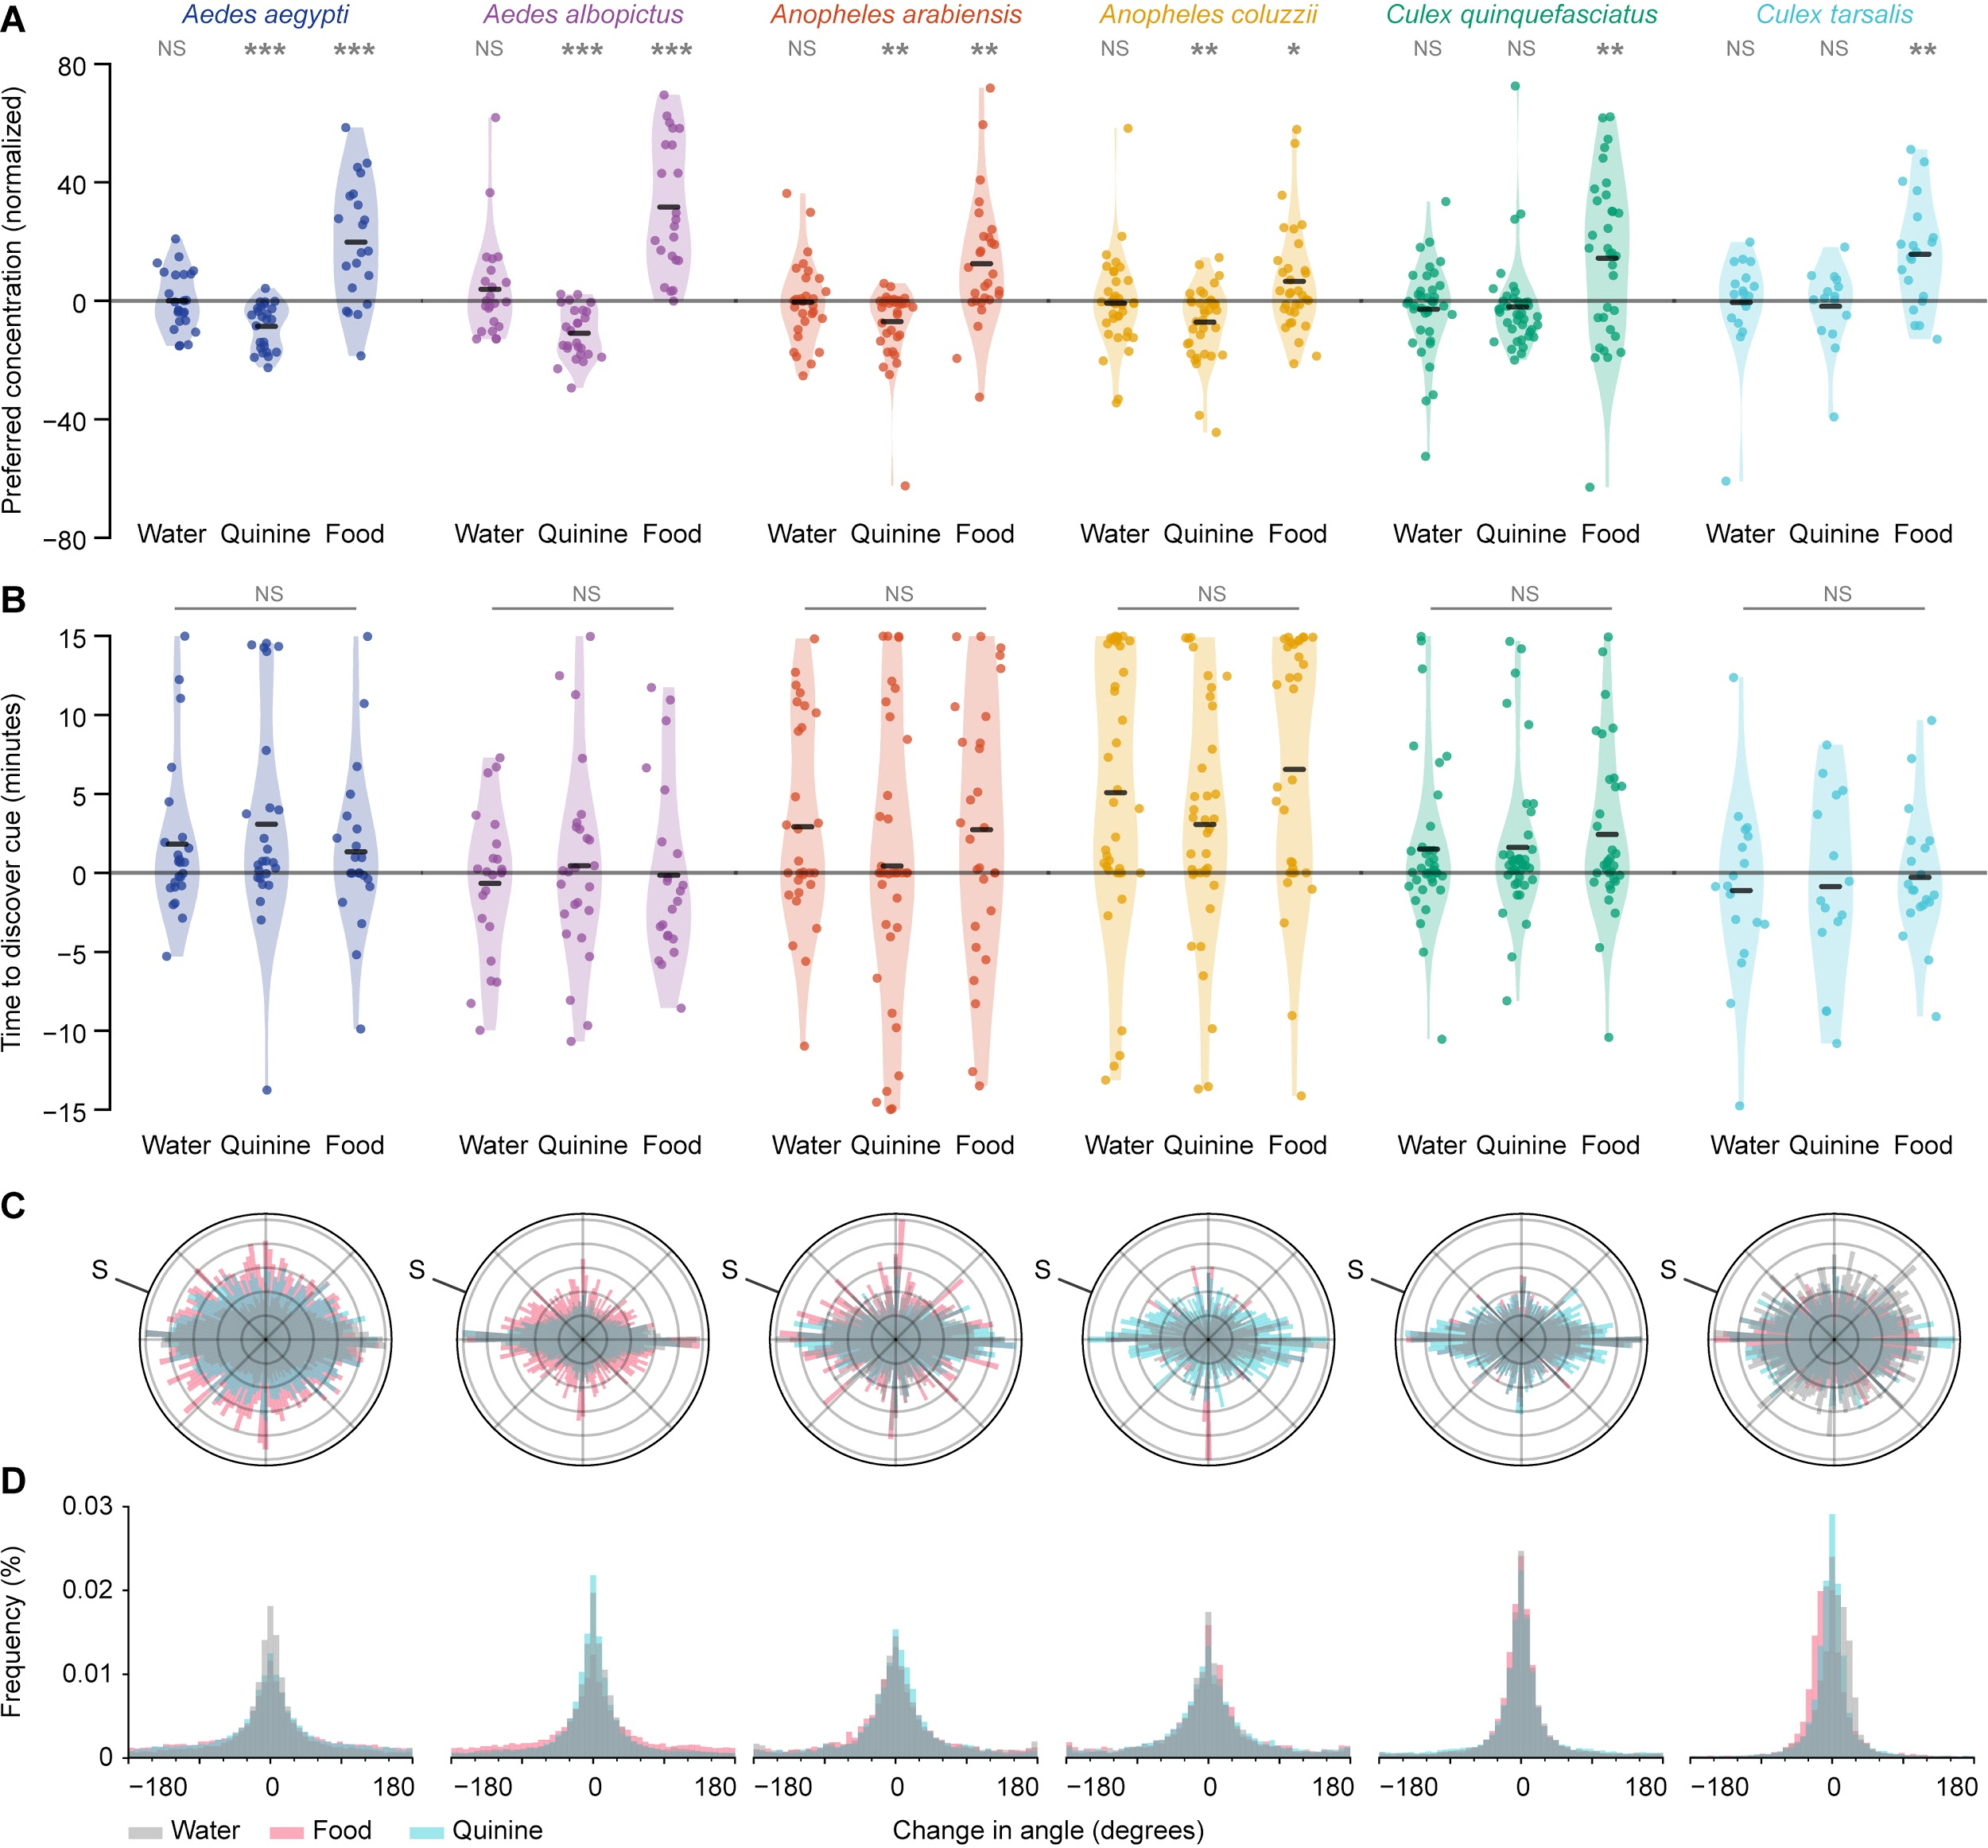

**Fig 4: Larval gathering near preferred cues is more consistent with passive exploration than active navigation. A:** All larval species were significantly attracted to food extract. With the exception of the two *Culex* species, larvae were also significantly repelled by the aversive tastant quinine. **B:** However, none of the six larval species were able to change their navigation behavior to find food faster, or delay occupying high-concentration areas of quinine: *Ae. aegypti* (p=0.60, Kruskal-Wallis test); *Ae. albopictus* (p=0.71); *An. arabiensis* (p=0.52); *An. coluzzii* (p=0.22); *C. quinquefasciatus* (p=0.64); *C. tarsalis* (p=0.93). **C:** For all species, animals did not appear to change their behavior to move towards or away from any stimuli. Polar plots showing orientation for all animals throughout the 15 minute experiment for water (grey), food (pink) or quinine (light blue). The label “S” marks the approximate direction of each stimulus. Each bar in the polar plot represents the proportion of time that animals moved in that specific direction. For visualization purposes, all polar plots are normalized to the maximum frequency for each stimulus. **D:** Turning frequency for each species did not appear to change depending on the added stimulus. Frequency histograms for exploratory larval turning frequency in response to the addition of water (grey), food (pink) or quinine (light blue). Y axis ranges are identical for all six plots. **C-D:** To reduce noise from passively drifting animals, plots only include data where larvae were moving at ≥1mm ⋅ s-1. Although our experiments did not have sufficient power to statistically inspect these differences, animals do not appear to significantly change orientation across stimuli.

**Table 1: Comparisons of swimming patterns among species.**

Values in upper right half of the matrix represent pseudo-F statistics from pairwise perMANOVA tests. Asterisks after each value indicate the significance of the corresponding p-value after Bonferroni correction: *: p<0.05; **: p<0.01; ***: p<0.001; no asterisk: not statistically significant. In the upper right, significant values with a high pseudo-F statistic represent species-species pairs that exhibit statistically significant differences in overall navigation behavior. Values in the lower left half of the matrix represent F statistics for a pairwise test of multivariate dispersion (ANOVA with Bonferroni correction). Significant values with a high F-statistic in the bottom half of the matrix represent species-species pairs with statistically significant differences in the intra-species variability of navigation behavior. These results suggest that some, but not all, of the observed differences between species-species pairs may be due to variance among individuals, rather than to differences in raw behavioral metrics.

|  |  |  |  |  |  |  |
| --- | --- | --- | --- | --- | --- | --- |
|  | *Aedes aegypti* | *Aedes albopictus* | *Anopheles arabiensis* | *Anopheles coluzzii* | *Culex quinquefasciatus* | *Culex tarsalis* |
| *Aedes aegypti* |  | 11.12 *** | 89.92 *** | 115.66 *** | 25.66 *** | 20.13 *** |
| *Aedes albopictus* | 5.54 |  | 99.66 *** | 118.58 *** | 38.73 *** | 16.96 *** |
| *Anopheles arabiensis* | 0.76 | 0.03 |  | 33.10 *** | 71.41 *** | 48.50 *** |
| *Anopheles coluzzii* | 1.44 | 6.79 | 18.19 *** |  | 69.04 *** | 63.56 *** |
| *Culex quinquefasciatus* | 4.90 | 18.77 *** | 21.33 *** | 0.06 |  | 29.69 *** |
| *Culex tarsalis* | 0.02 | 4.84 | 0.22 | 3.15 | 3.21 |  |

**Supplementary Figures**

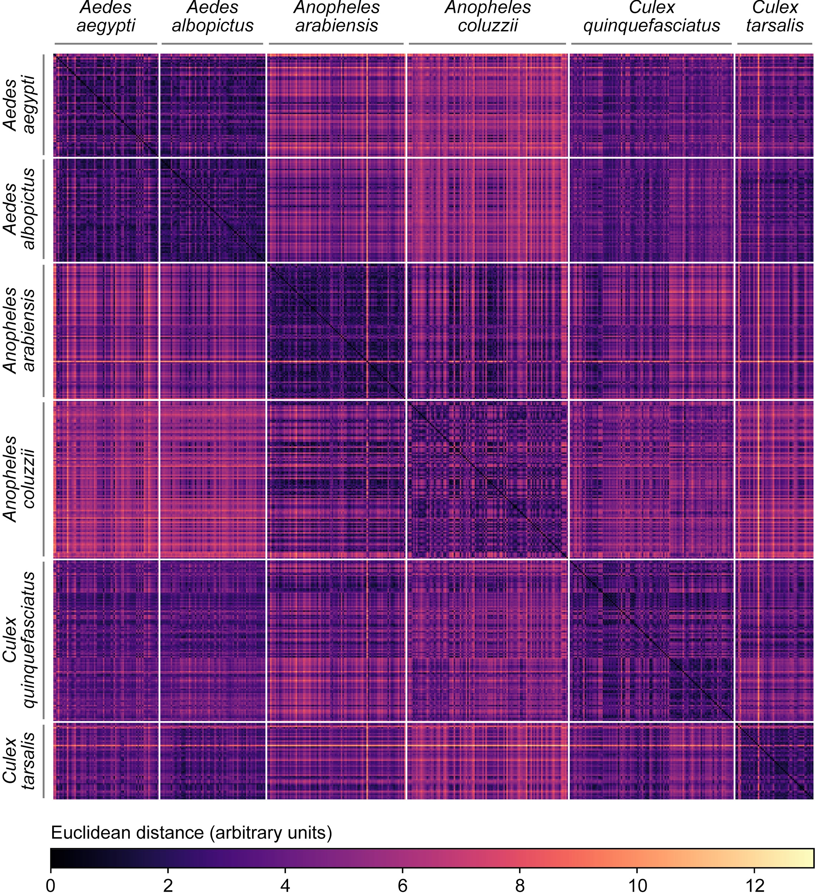

**Fig S1: Euclidean distance matrix of individual differences between larvae.**

Euclidean distance matrix incorporating all ten navigation behavior variables in clean water. Each row or column visualizes one individual larvae, arranged in species groups and then in order of experiment date. White lines mark boundaries between different species. Higher Euclidean distances (arbitrary units) represent lower similarity between individuals. The diagonal of black cells (upper left corner to the lower right corner) indicate self-self comparisons (distance = 0).

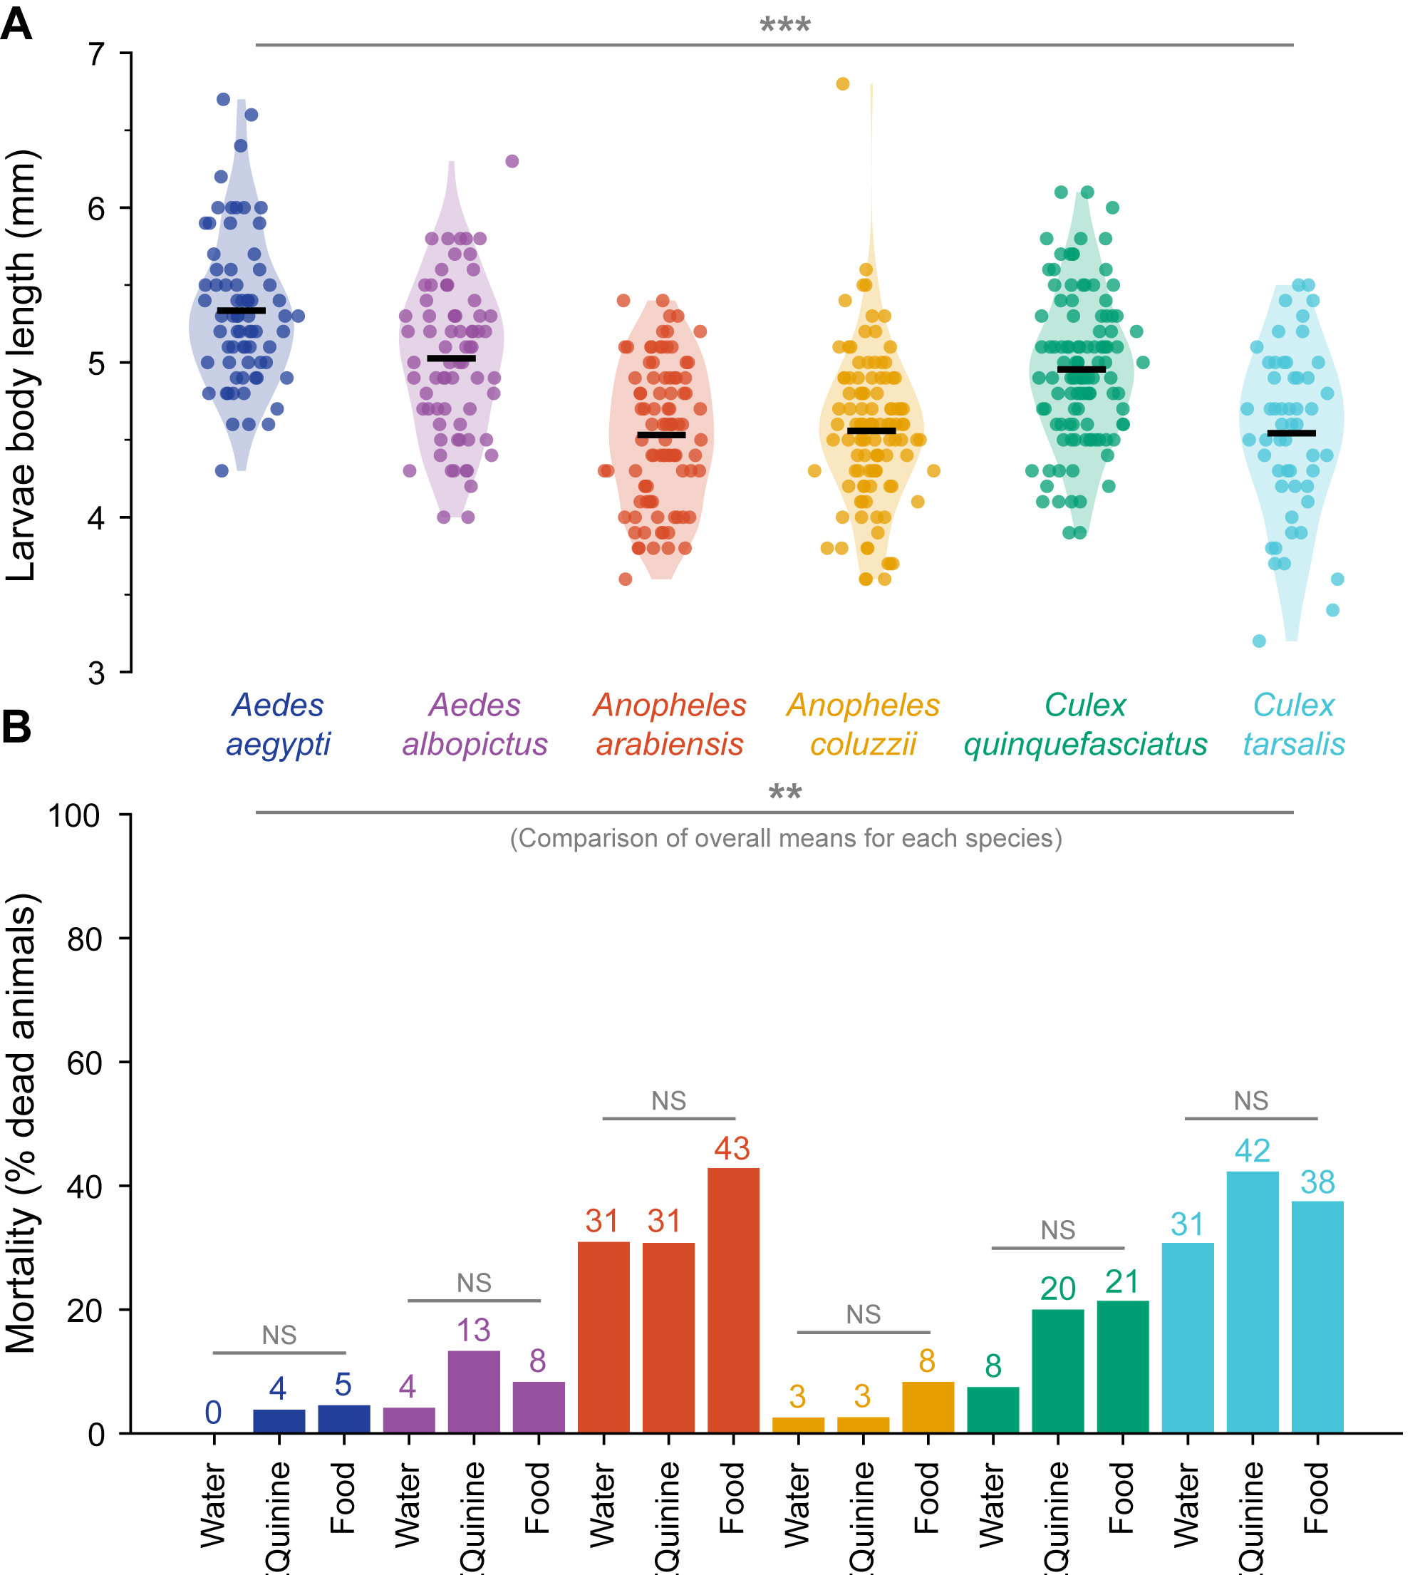

**Fig S2: Larval size and mortality are significantly different across species.**

**A:** Size of starved L3 larvae differed significantly across species (p<0.001, Kruskal-Wallis test with Bonferroni correction). Scatter points depict individual larvae, colored by species from left to right: *Ae. aegypti* (navy, n=67, mean=5.33mm), *Ae. albopictus* (purple, n=70, mean=5.03mm), *An. arabiensis* (red, n=93, mean=4.53mm), *An. coluzzii* (yellow, n=108, mean=4.56mm), *C. quinquefasciatus* (green, n=110, mean=4.95mm), and *C. tarsalis* (aqua, n=53, mean=4.54mm). Horizontal black bars visualize the mean of each group. Due to these size differences across species, speed measurements were standardized to larval body size for each individual. **B:** Post-experiment mortality for each species and treatment. Numbers shown above each bar mark the percentage value for each treatment. Differences were statistically significant across species (p=0.003, Fisher’s Exact Test with Holm-Bonferroni correction), but not across the three treatments for the same species (p=1 for all species). Asterisks indicate the significance of the corresponding p-value: *: p<0.05; **: p<0.01; ***: p<0.001; NS: not statistically significant. All animals that died before eclosion (shown here) were omitted from analyses.

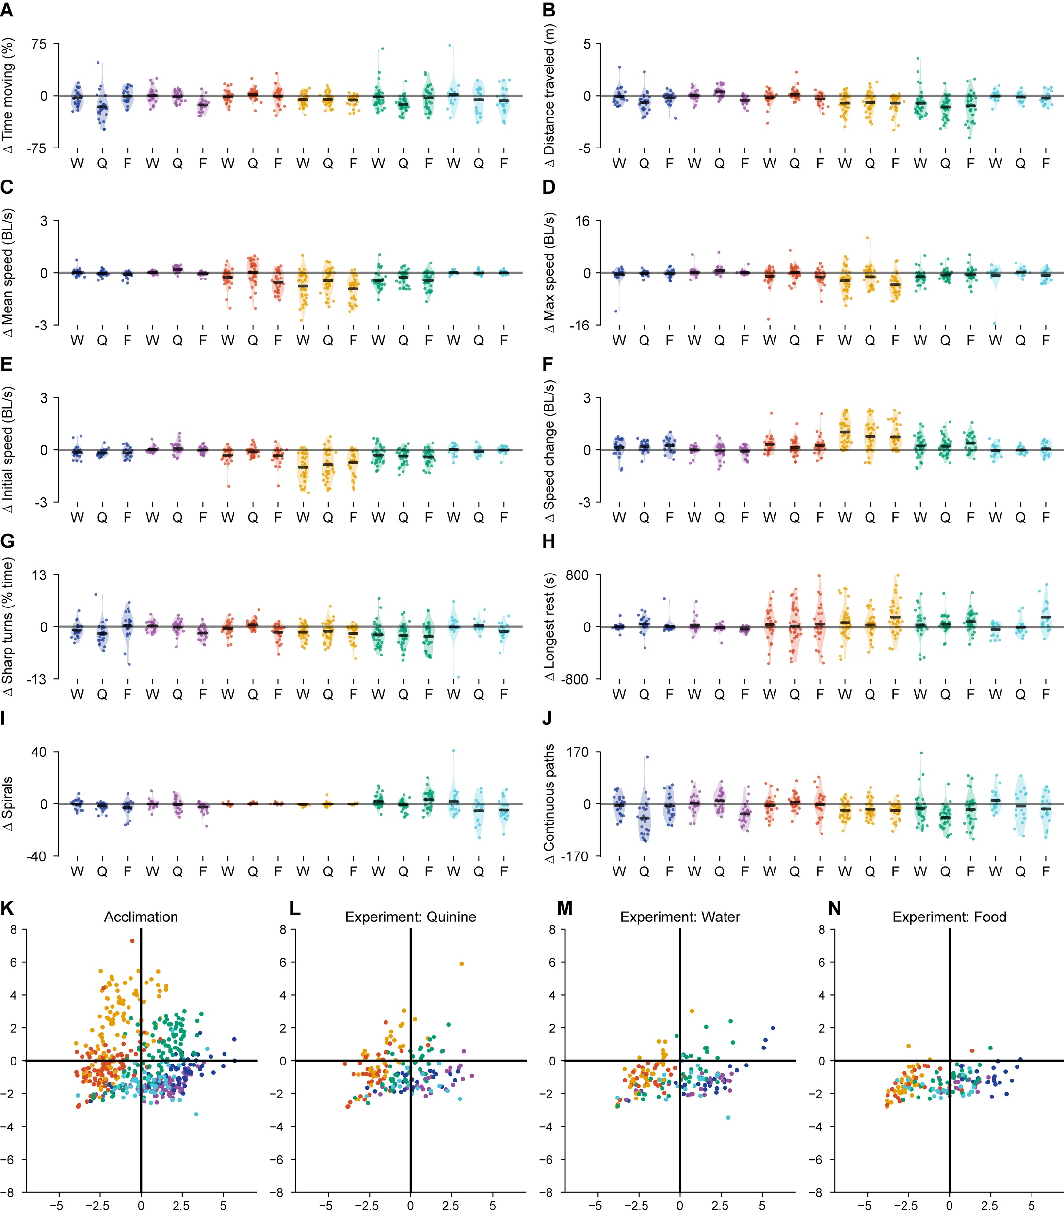

**Fig S3: Changes in kinematic swimming responses following stimulus addition.**

**A-J:** Changes in each of the ten navigational behavior measurements following the addition of water (W), quinine (Q), or food extract (F). From left to right in all plots: *Ae. aegypti* (navy); *Ae. albopictus* (purple); *An. arabiensis* (red); *An. coluzzii* (yellow); *C. quinquefasciatus* (green); and *C. tarsalis* (aqua). Each scatter point represents one individual, and the y axis shows the change in the navigational variable (experiment period - acclimation period). Thus, a point lying at 0 represents no change in behavior following addition of the stimulus. **A:** Time spent moving (%) **B:** Total distance traveled (meters) **C:** Mean speed when moving (body lengths⋅s-1 [BL/s]) **D:** Maximum speed (body lengths⋅s-1[BL/s]) **E:** Initial speed, or mean speed in first minute (body lengths⋅s-1[BL/s]) **F:** Speed modification, or difference in mean speed between first and last minutes (body lengths⋅s-1[BL/s]) **G:** Sharp turns (% total time spent turning >45°) **H:** Longest continuous rest period **I:** Number of spirals **J:** Number of continuous paths that are not spirals. **K-N:** Representation of the same ten variables as in **A-J**, in PCA space. **K:** Reproduction of acclimation data for all animals visualized in Fig 3A. **L:** Experiment data from all animals responding to quinine, reprojected into the same PC space as in **K**. **M:** Experiment data from all animals responding to water, reprojected into the same PC space as in **K**. **N:** Experiment data from all animals responding to food, reprojected into the same PC space as in **K**.

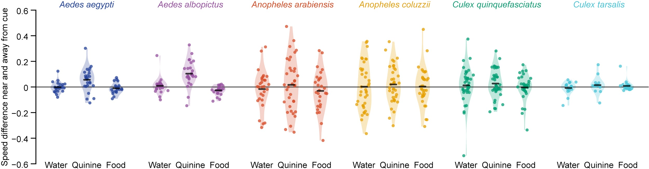

**Fig S4: Species exhibit potential differences in navigation strategy toward preferred areas.**

In a previous study, we conducted deep analyses into the mechanism of *Ae. aegypti* navigation, using a dataset of over 500 individual animals observed independently. This study revealed that *Ae. aegypti* locate preferred cues by decreasing their movement speed near preferred areas. In this current study, we did not have the reagent resources or manpower to conduct the 3,000 experiments necessary for an equally robust analysis. Nevertheless, we visualized the speed near and far from cues for each species and each stimulus. In this graph, each scatter point represents one individual, and the y axis shows the change in speed near the experimental cue (speed in areas >50% concentration - speed in areas <50% concentration), normalized to larval behavior in corresponding sections of the arena in the 15 minute acclimation period.

**Fig S5 (following page): Larval distribution and trajectory maps for all species and experimental conditions. A-F:** Distribution histograms across the x axis (above) and trajectory maps (below) of all starved animals during the experiment phase for water (left column), quinine (center column), and food (right column); *Ae. aegypti* (**A**), *Ae. albopictus* (**B**), *An. arabiensis* (**C**), *An. coluzzii* (**D**), *C. quinquefasciatus* (**E**), and *C. tarsalis* (**F**). Although trajectories are shown aggregated into one image for each panel, all animals were tested individually. Scatter points show the position of each animal at the end of the experiment. It is important to note that these histograms show the aggregated position data from all animals throughout the entire 15 minute experiment. Thus, a single animal exhibiting strong attraction or aversion may disproportionately influence this data visualization. For statistical tests reported in this paper, a single preference value was calculated for each animal (Fig 4A) to avoid such effects. Note that the distribution histograms for *An. arabiensis* and *An. coluzzii* appear particularly sparse, because these two *Anopheles* species spent the majority of the experiment at rest.

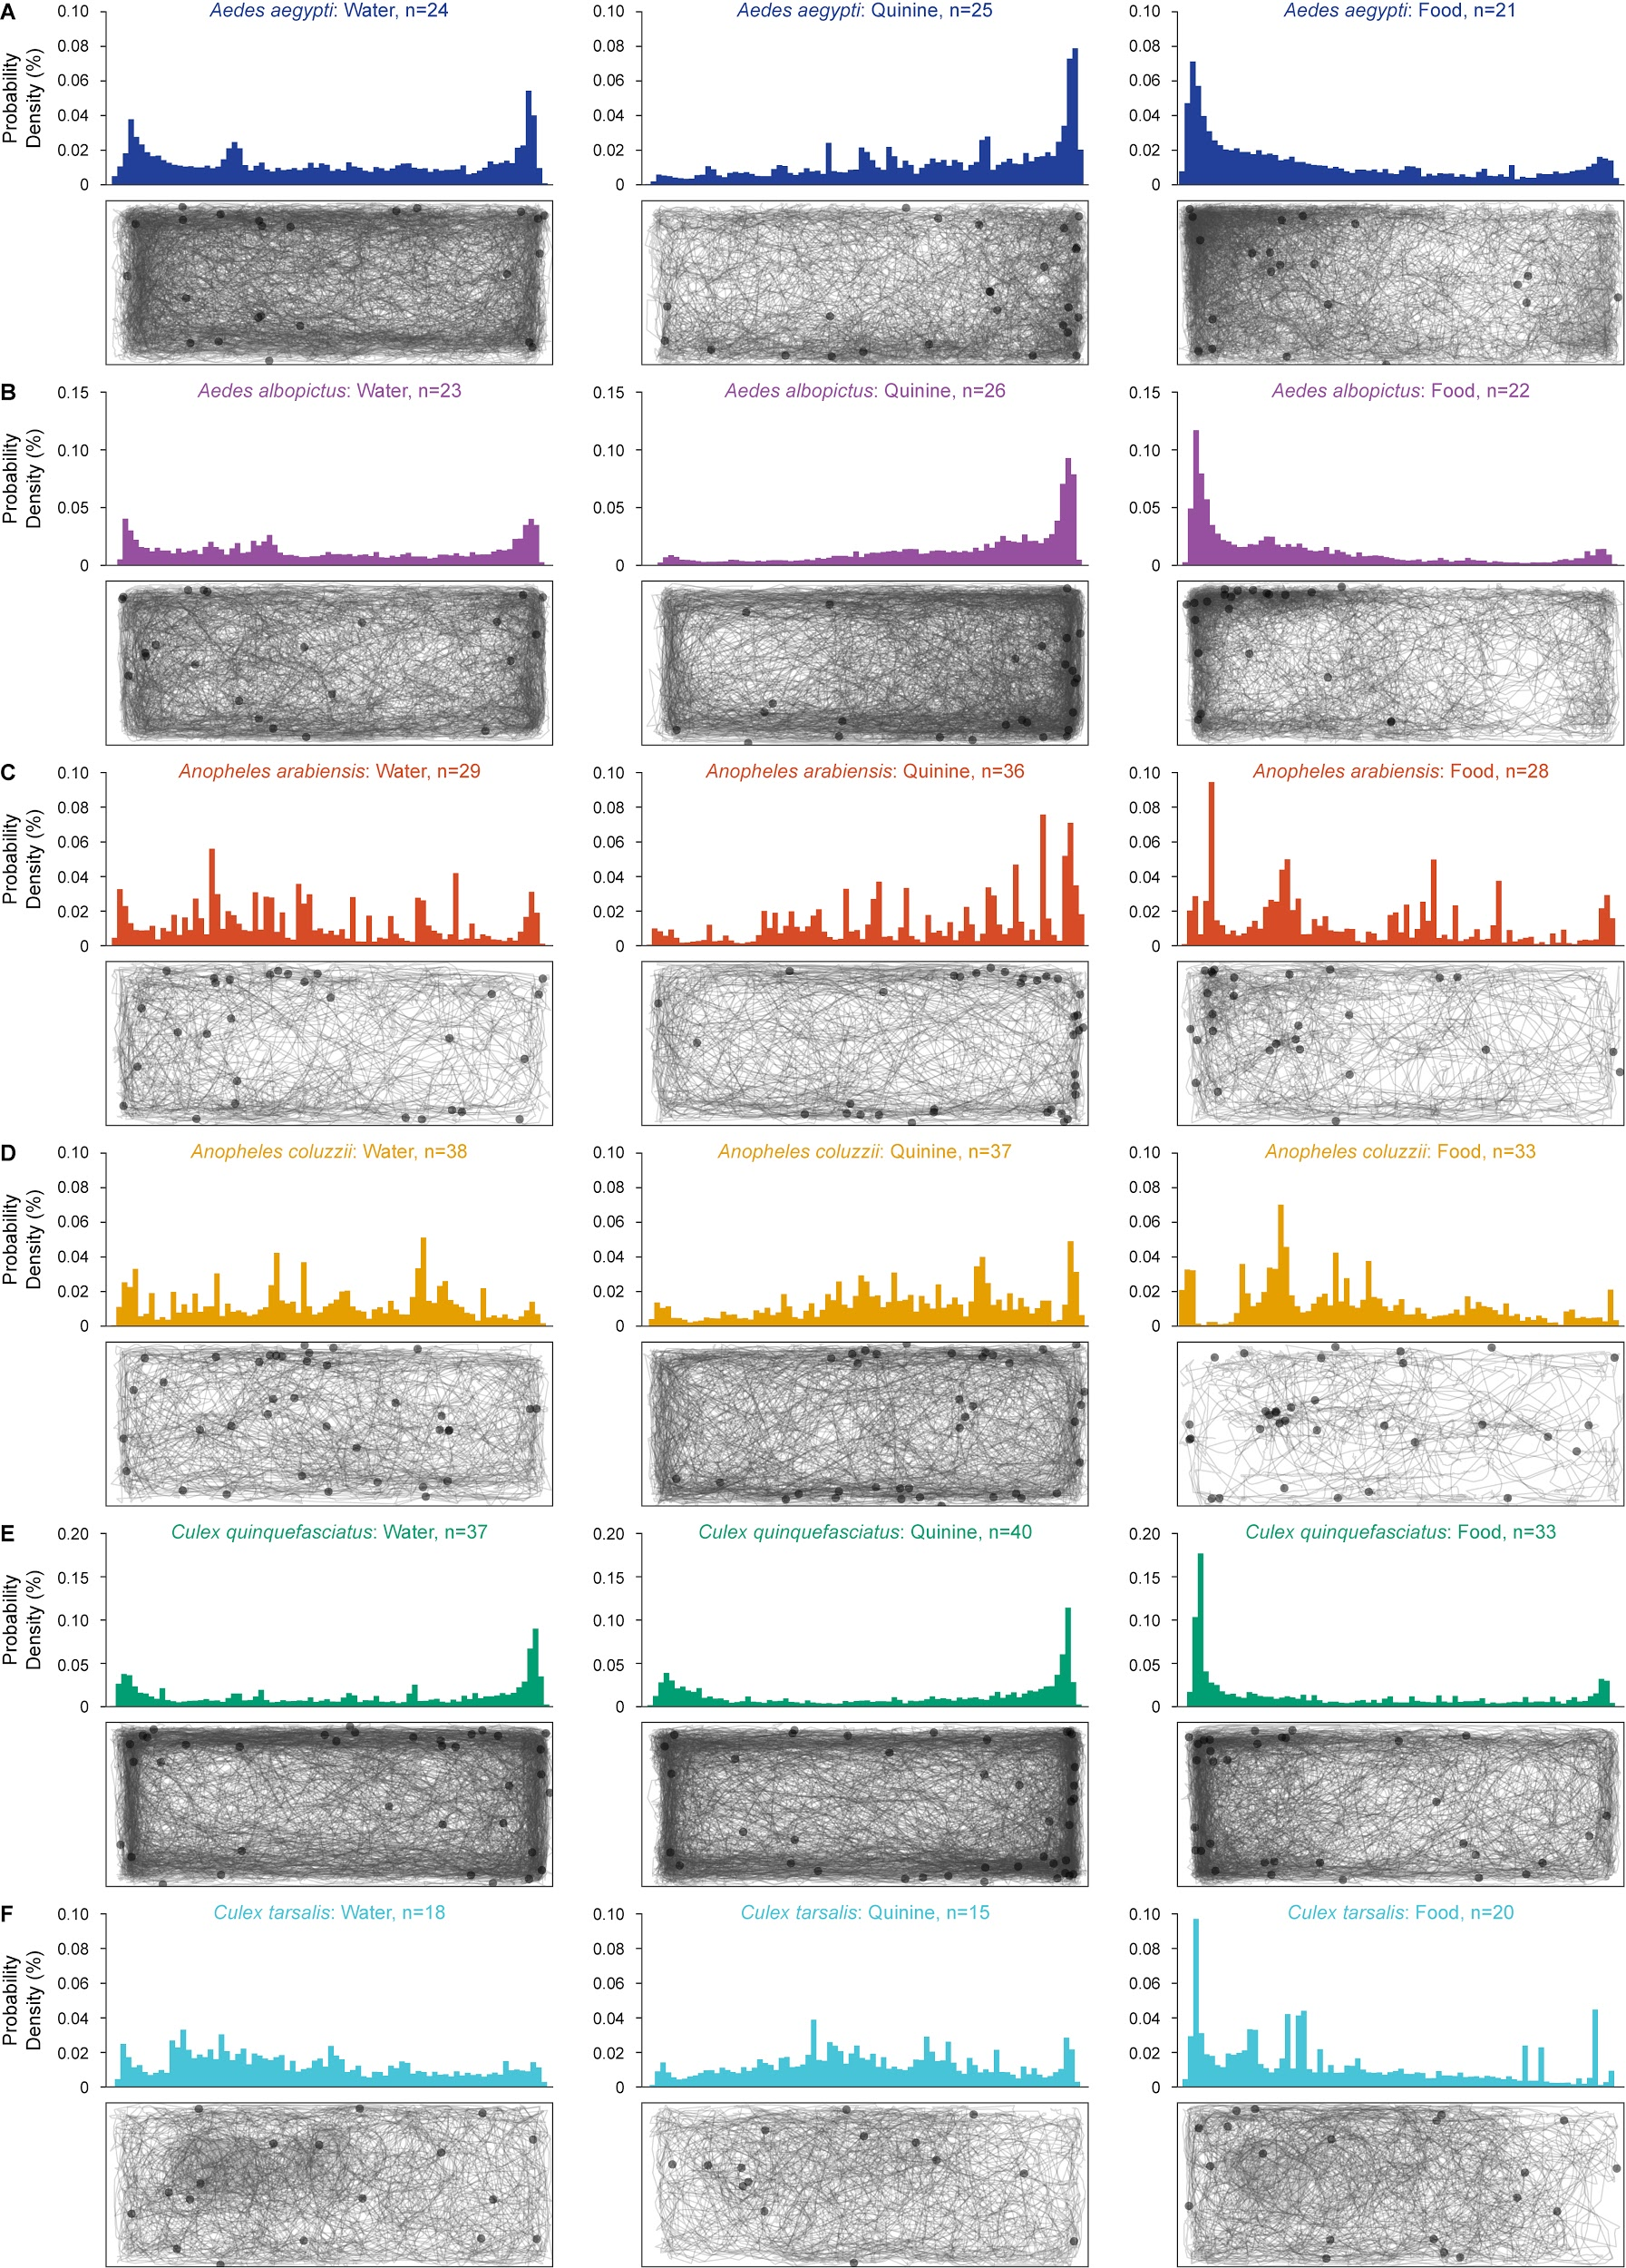

**References**

1. [Weeks, E. N., Baniszewski, J., Gezan, S. A., Allan, S. A., Cuda, J. P. & Stevens, B. R. Methionine as a safe and effective novel biorational mosquito larvicide. *Pest Manag. Sci.* **75,** 346–355 (2019).](http://paperpile.com/b/iwdgYc/0pGC)

2. [Regis, L., da Silva, S. B. & Melo-Santos, M. A. The use of bacterial larvicides in mosquito and black fly control programmes in Brazil. *Mem. Inst. Oswaldo Cruz* **95 Suppl 1,** 207–210 (2000).](http://paperpile.com/b/iwdgYc/c8p0)

3. [Hartman, M. F. Malaria Mosquito Larvae in Competition for Limited Resources. (2016). at <](http://paperpile.com/b/iwdgYc/Ctr8)<https://oaktrust.library.tamu.edu/handle/1969.1/164484>[>](http://paperpile.com/b/iwdgYc/Ctr8)

4. [Ramoska, W. A. & Hopkins, T. L. Effects of mosquito larval feeding behavior on Bacillus sphaericus efficacy. *J. Invertebr. Pathol.* **37,** 269–272 (1981).](http://paperpile.com/b/iwdgYc/I0BL)

5. [Merritt, R. W., Dadd, R. H. & Walker, E. D. Feeding behavior, natural food, and nutritional relationships of larval mosquitoes. *Annu. Rev. Entomol.* **37,** 349–376 (1992).](http://paperpile.com/b/iwdgYc/GHhw)

6. [Bevins, S. N. Invasive mosquitoes, larval competition, and indirect effects on the vector competence of native mosquito species (Diptera: Culicidae). *Biol. Invasions* **10,** 1109–1117 (2008).](http://paperpile.com/b/iwdgYc/KxL2)

7. [Alto, B. W., Lounibos, L. P., Higgs, S. & Juliano, S. A. Larval competition differentially affects arbovirus infection in Aedes mosquitoes. *Ecology* **86,** 3279–3288 (2005).](http://paperpile.com/b/iwdgYc/ZzoS)

8. [Yee, D. A., Kesavaraju, B. & Juliano, S. A. Larval feeding behavior of three co-occurring species of container mosquitoes. *J. Vector Ecol.* **29,** 315 (2004).](http://paperpile.com/b/iwdgYc/PnSR)

9. [Skiff, J. J. & Yee, D. A. Behavioral differences among four co-occurring species of container mosquito larvae: effects of depth and resource environments. *J. Med. Entomol.* **51,** 375–381 (2014).](http://paperpile.com/b/iwdgYc/a5qV)

10. [Reiskind, M. H. & Shawn Janairo, M. Tracking Aedes aegypti (Diptera: Culicidae) Larval Behavior Across Development: Effects of Temperature and Nutrients on Individuals’ Foraging Behavior. *J. Med. Entomol.* (2018). doi:](http://paperpile.com/b/iwdgYc/xjtF)[10.1093/jme/tjy073](http://dx.doi.org/10.1093/jme/tjy073)

11. [Zahouli, J. B. Z., Koudou, B. G., Müller, P., Malone, D., Tano, Y. & Utzinger, J. Urbanization is a main driver for the larval ecology of Aedes mosquitoes in arbovirus-endemic settings in south-eastern Côte d’Ivoire. *PLoS Negl. Trop. Dis.* **11,** e0005751 (2017).](http://paperpile.com/b/iwdgYc/11xn)

12. [Juliano, S. A. Species interactions among larval mosquitoes: context dependence across habitat gradients. *Annu. Rev. Entomol.* **54,** 37–56 (2009).](http://paperpile.com/b/iwdgYc/Ki6L)

13. [Workman, P. D. & Walton, W. E. Larval behavior of four Culex (Diptera: Culicidae) associated with treatment wetlands in the southwestern United States. *J. Vector Ecol.* **28,** 213–228 (2003).](http://paperpile.com/b/iwdgYc/CcWZ)

14. [Lutz, E. K., Grewal, T. S. & Riffell, J. A. Computational and experimental insights into the chemosensory navigation of Aedes aegypti mosquito larvae. *bioRxiv* 585075 (2019). doi:](http://paperpile.com/b/iwdgYc/WxZw)[10.1101/585075](http://dx.doi.org/10.1101/585075)

15. [Aly, C. & Mulla, S. Orientation and ingestion rates of larval Anopheles albimanus in response to floating particles. *Entomol. Exp. Appl.* **42,** 83–90 (1986).](http://paperpile.com/b/iwdgYc/7Vv8)

16. [Aly, C. Feeding rate of larval Aedes vexans stimulated by food substances. *J. Am. Mosq. Control Assoc.* **1,** 506–510 (1985).](http://paperpile.com/b/iwdgYc/2URz)

17. [Takken, W. & Knols, B. G. J. *Olfaction in Vector-host Interactions*. (Wageningen Academic Pub, 2010).](http://paperpile.com/b/iwdgYc/s0sy)

18. [Ruzzante, L., Reijnders, M. J. M. F. & Waterhouse, R. M. Of Genes and Genomes: Mosquito Evolution and Diversity. *Trends Parasitol.* **35,** 32–51 (2019).](http://paperpile.com/b/iwdgYc/afsZ)

19. [Christophers, S. *Aedes aegypti (L.) the yellow fever mosquito: its life history, bionomics and structure*. (Cambridge University Press, 1960).](http://paperpile.com/b/iwdgYc/fqZ5)

20. [Mousson, L., Dauga, C., Garrigues, T., Schaffner, F., Vazeille, M. & Failloux, A.-B. Phylogeography of Aedes (Stegomyia) aegypti (L.) and Aedes (Stegomyia) albopictus (Skuse) (Diptera: Culicidae) based on mitochondrial DNA variations. *Genet. Res.* **86,** 1–11 (2005).](http://paperpile.com/b/iwdgYc/k6TQ)

21. [Minakawa, N., Beier, J. C., Githure, J. I., Mutero, C. M. & Yan, G. Spatial distribution and habitat characterization of Anopheline mosquito larvae in Western Kenya. *Am. J. Trop. Med. Hyg.* **61,** 1010–1016 (1999).](http://paperpile.com/b/iwdgYc/5z7P)

22. [Etang, J., Mbida, A. M., Akono, P. N., Binyang, J., Moukoko, C. E. E., Lehman, L. G., Awono-Ambene, P., Talipouo, A., Eyisab, W. E., Tagne, D., Tchoffo, R., Manga, L. & Mimpfoundi, R. Anopheles coluzzii larval habitat and insecticide resistance in the island area of Manoka, Cameroon. *BMC Infect. Dis.* **16,** 217 (2016).](http://paperpile.com/b/iwdgYc/6rwG)

23. [Van Dam, A. R. & Walton, W. E. The effect of predatory fish exudates on the ovipostional behaviour of three mosquito species:Culex quinquefasciatus,Aedes aegyptiandCulex tarsalis. *Med. Vet. Entomol.* **22,** 399–404 (2008).](http://paperpile.com/b/iwdgYc/ZNNh)

24. [Chan, K. L., Ho, B. C. & Chan, Y. C. Aedes aegypti (L.) and Aedes albopictus (Skuse) in Singapore City. 2. Larval habitats. *Bull. World Health Organ.* **44,** 629–633 (1971).](http://paperpile.com/b/iwdgYc/qU3a)

25. [Minakawa, N., Sonye, G., Mogi, M. & Yan, G. Habitat characteristics of Anopheles gambiae s.s. larvae in a Kenyan highland. *Medical and Veterinary Entomology* **18,** 301–305 (2004).](http://paperpile.com/b/iwdgYc/itOx)

26. [Bell, W. J. Searching Behavior Patterns in Insects. *Annu. Rev. Entomol.* **35,** 447–467 (1990).](http://paperpile.com/b/iwdgYc/v51v)

27. [Bui, M., Shyong, J., Lutz, E. K., Yang, T., Li, M., Truong, K., Arvidson, R., Buchman, A., Riffell, J. A. & Akbari, O. S. Live calcium imaging of Aedes aegypti neuronal tissues reveals differential importance of chemosensory systems for life-history-specific foraging strategies. *BMC Neurosci.* **20,** 27 (2019).](http://paperpile.com/b/iwdgYc/bAfU)

28. [Juliano, S. A. Species introduction and replacement among mosquitoes: interspecific resource competition or apparent competition? *Ecology* **79,** 255–268 (1998).](http://paperpile.com/b/iwdgYc/cG4x)

29. [Braks, M. A. H., Honório, N. A., Lounibos, L. P., Lourenço-De-Oliveira, R. & Juliano, S. A. Interspecific Competition Between Two Invasive Species of Container Mosquitoes, Aedes aegypti and Aedes albopictus (Diptera: Culicidae), in Brazil. *Ann. Entomol. Soc. Am.* **97,** 130–139 (2004).](http://paperpile.com/b/iwdgYc/paYc)

30. [Riabinina, O., Task, D., Marr, E., Lin, C.-C., Alford, R., O’Brochta, D. A. & Potter, C. J. Organization of olfactory centres in the malaria mosquito Anopheles gambiae. *Nature Communications* **7,** (2016).](http://paperpile.com/b/iwdgYc/IXFo)

31. [Matthews, B. J. & Vosshall, L. B. How to turn an organism into a model organism in 10 ‘easy’ steps. *The Journal of Experimental Biology* **223,** jeb218198 (2020).](http://paperpile.com/b/iwdgYc/i6np)

32. [van Breugel, F., Huda, A. & Dickinson, M. H. Distinct activity-gated pathways mediate attraction and aversion to CO2 in Drosophila. *Nature* **564,** 420–424 (2018).](http://paperpile.com/b/iwdgYc/LBMV)

33. [Sih, A. Antipredator Responses and the Perception of Danger by Mosquito Larvae. *Ecology* **67,** 434–441 (1986).](http://paperpile.com/b/iwdgYc/azyy)

34. [R Foundation for Statistical Computing. R: A language and environment for statistical computing. (2015).](http://paperpile.com/b/iwdgYc/d7yq)

35. [Python Core Team. Python: A dynamic, open source programming language. *Python Software Foundation* **78,** (2015).](http://paperpile.com/b/iwdgYc/1Uos)